**Writing First Code on Emmet**

# Lecture CheckList

1. Introduction to Emmet.
2. HTML starter code using emmet.

# Introduction to Emmet.

Emmet is a plugin for text editors that allows you to expand abbreviations into HTML, XML, and other code structures. It can save you a lot of time by allowing you to type abbreviations that are automatically expanded into full code structures.

# To use Emmet to generate HTML starter code in Visual Studio Code, follow these steps:

1. Open Visual Studio Code and create a new file or open an existing file.
2. Type the Emmet abbreviation: This code uses the Operator “!” to create the default body for HTML code.
3. Press the “Expand Abbreviation” button or key (Tab key).
4. This will expand the abbreviation into the following HTML starter code.

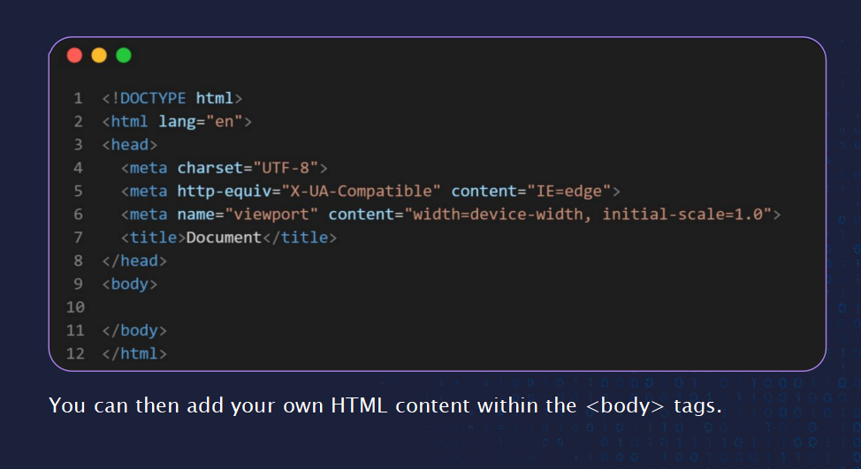

**THANK YOU**